Unit 4
Assignment
Long Vy
Purdue Global
IN450 – Advanced Software Development Using Python
Brian Myers
April 21, 2026
Module.py
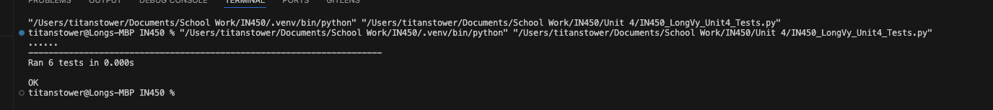

Test.py
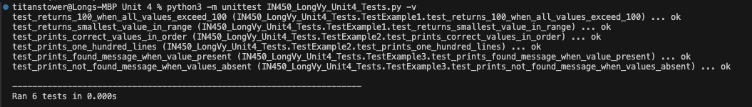

References
Azkia, D. (2025, April 29). Bug tracking management for QA teams: Let’s get it right | by Devy Azkia | Medium. Medium. https://devyazkia.medium.com/bug-tracking-management-for-qa-teams-lets-get-it-right-b4f3e7cfe129
GeeksforGeeks. (2025, July 15). Python unittest - assertequal() function. https://www.geeksforgeeks.org/python/python-unittest-assertequal-function/
Obregon, A. (2024, May 31). Writing unit tests in python with unittest. https://medium.com/@AlexanderObregon/writing-unit-tests-in-python-with-unittest-0a23463d93dd
Qiang, B. (2016, October 27). The absolute beginner’s guide to test driven development, with a practical example | by Beth Qiang | Medium. Medium. https://medium.com/@bethqiang/the-absolute-beginners-guide-to-test-driven-development-with-a-practical-example-c39e73a11631

